Name Date
Stage 9 End of unit 8 test
A calculator must not be used during this test.
1 Here are five fraction cards:
A
B
C
D
E
Write down which cards have
a terminating decimals
[2]
b recurring decimals.
[2]
2 Work out these calculations. Write each answer as a mixed number in its simplest form.
Show all the steps in your working.
a

[2]

b

[2]
c

[2]
3 The diagram shows a compound shape made of a square joined to a rectangle.
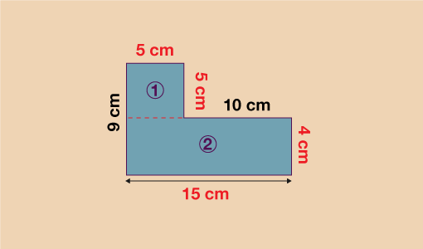

a Write the calculation that you must do to work out the total area of the shape.
[2]
b Work out the area of the shape.

[2]
4 Work out these multiplications. Cancel common factors before multiplying.
a
[2]
b
[2]

c
[2]
5 Sarah wants to determine if adults in her town eat a healthy diet. She stands outside a popular fast-food burger restaurant on a Saturday night and surveys 10 people leaving the restaurant.
Give two reasons why this is not a good sample.
- ………………………………………………………..
- ………………………………………………………………

6 The diagram shows a cuboid.
Work out the volume of the cuboid.
Show all your working
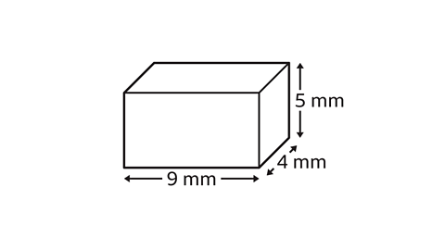

7 The diagram shows a rectangle.
Work out the area of the rectangle.
Show all your working.
